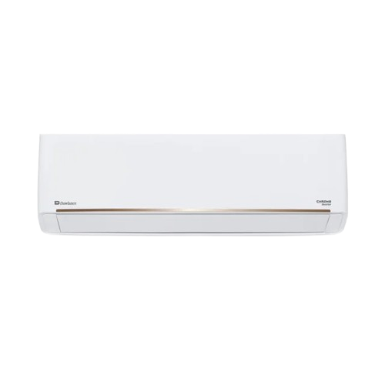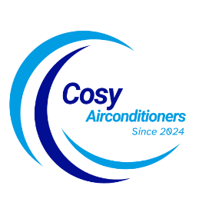

SKU: DSU-18HFCF/013USDC (W)

**Frost 1.5 Ton Cool Only Inverter Split AC**

~~Rs 145,999.00~~ Rs 122,999.00

Anti Corrosion 100%copper

Wide Voltage With Hyper PCB

Self Cleaning

With adoption of optimized cooling system, the cooling capacity of Haier Air Conditioners still could catch up 100% to provide the best cooling experience to user at 46◦C high temperature.

**Product details**

**THANK YOU!**

**WELLCOME TO OUR WEBSITE**